NORTH SOUTH UNIVERSITY
Committed to the highest standards of academic excellence

Course: CSE225.L
SPRING-23
Section: 09
Date:12/04/2023
^{ASSIGNMENT}
Submitted to
Jannatul Ferdaous(Lab Instructor CSE225.L)
North South University (NSU)
Submitted by
Israt Zaman Srity-2211084042

main.cpp
#include <iostream>
#include "quetype.cpp"

using namespace std;

int main()
{

QueType<int> queue(5);

if(queue.IsEmpty())
cout << "Queue is Empty" << endl;
else
cout << "Queue is not Empty" << endl;

int item;

cout << "Enter 4 integers: ";

for(int i=0;i<4;i++)
{
cin >> item;
queue.Enqueue(item);
}

if(queue.IsEmpty())
cout << "Queue is Empty" << endl;
else
cout << "Queue is not Empty" << endl;

if(queue.IsFull())
cout << "Queue is Full" << endl;
else
cout << "Queue is not Full" << endl;

cout << "Insert another integer: ";
cin >> item;
queue.Enqueue(item);

QueType<int> tempQueue;

while(!queue.IsEmpty())
{
queue.Dequeue(item);
tempQueue.Enqueue(item);
cout<<item<<" ";
}
cout<<endl;

while(!tempQueue.IsEmpty())
{
tempQueue.Dequeue(item);
queue.Enqueue(item);
}

if(queue.IsFull())
cout << "Queue is Full" << endl;
else
cout << "Queue is not Full" << endl;

try
{
cout << "Insert another integer: ";
cin >> item;
queue.Enqueue(item);
}catch(FullQueue)
{
cout << "Queue Overflow" << endl;
}

for(int i=0;i<2;i++)
queue.Dequeue(item);

while(!queue.IsEmpty())
{
queue.Dequeue(item);
tempQueue.Enqueue(item);
cout<<item<<" ";
}
cout<<endl;

while(!tempQueue.IsEmpty())
{
tempQueue.Dequeue(item);
queue.Enqueue(item);
}

for(int i=0;i<3;i++)
queue.Dequeue(item);

if(queue.IsEmpty())
cout << "Queue is Empty" << endl;
else
cout << "Queue is not Empty" << endl;

try
{
queue.Dequeue(item);
}catch(EmptyQueue)
{
cout << "Queue Underflow" << endl;
}

int n;
cout << "Enter n: ";
cin >> n;

string binary;
QueType<string> strQueue;
strQueue.Enqueue("1");

while(n > 0)
{

strQueue.Dequeue(binary);
cout << binary << endl;
strQueue.Enqueue(binary+"0");
strQueue.Enqueue(binary+"1");
n--;
}

return 0;
}

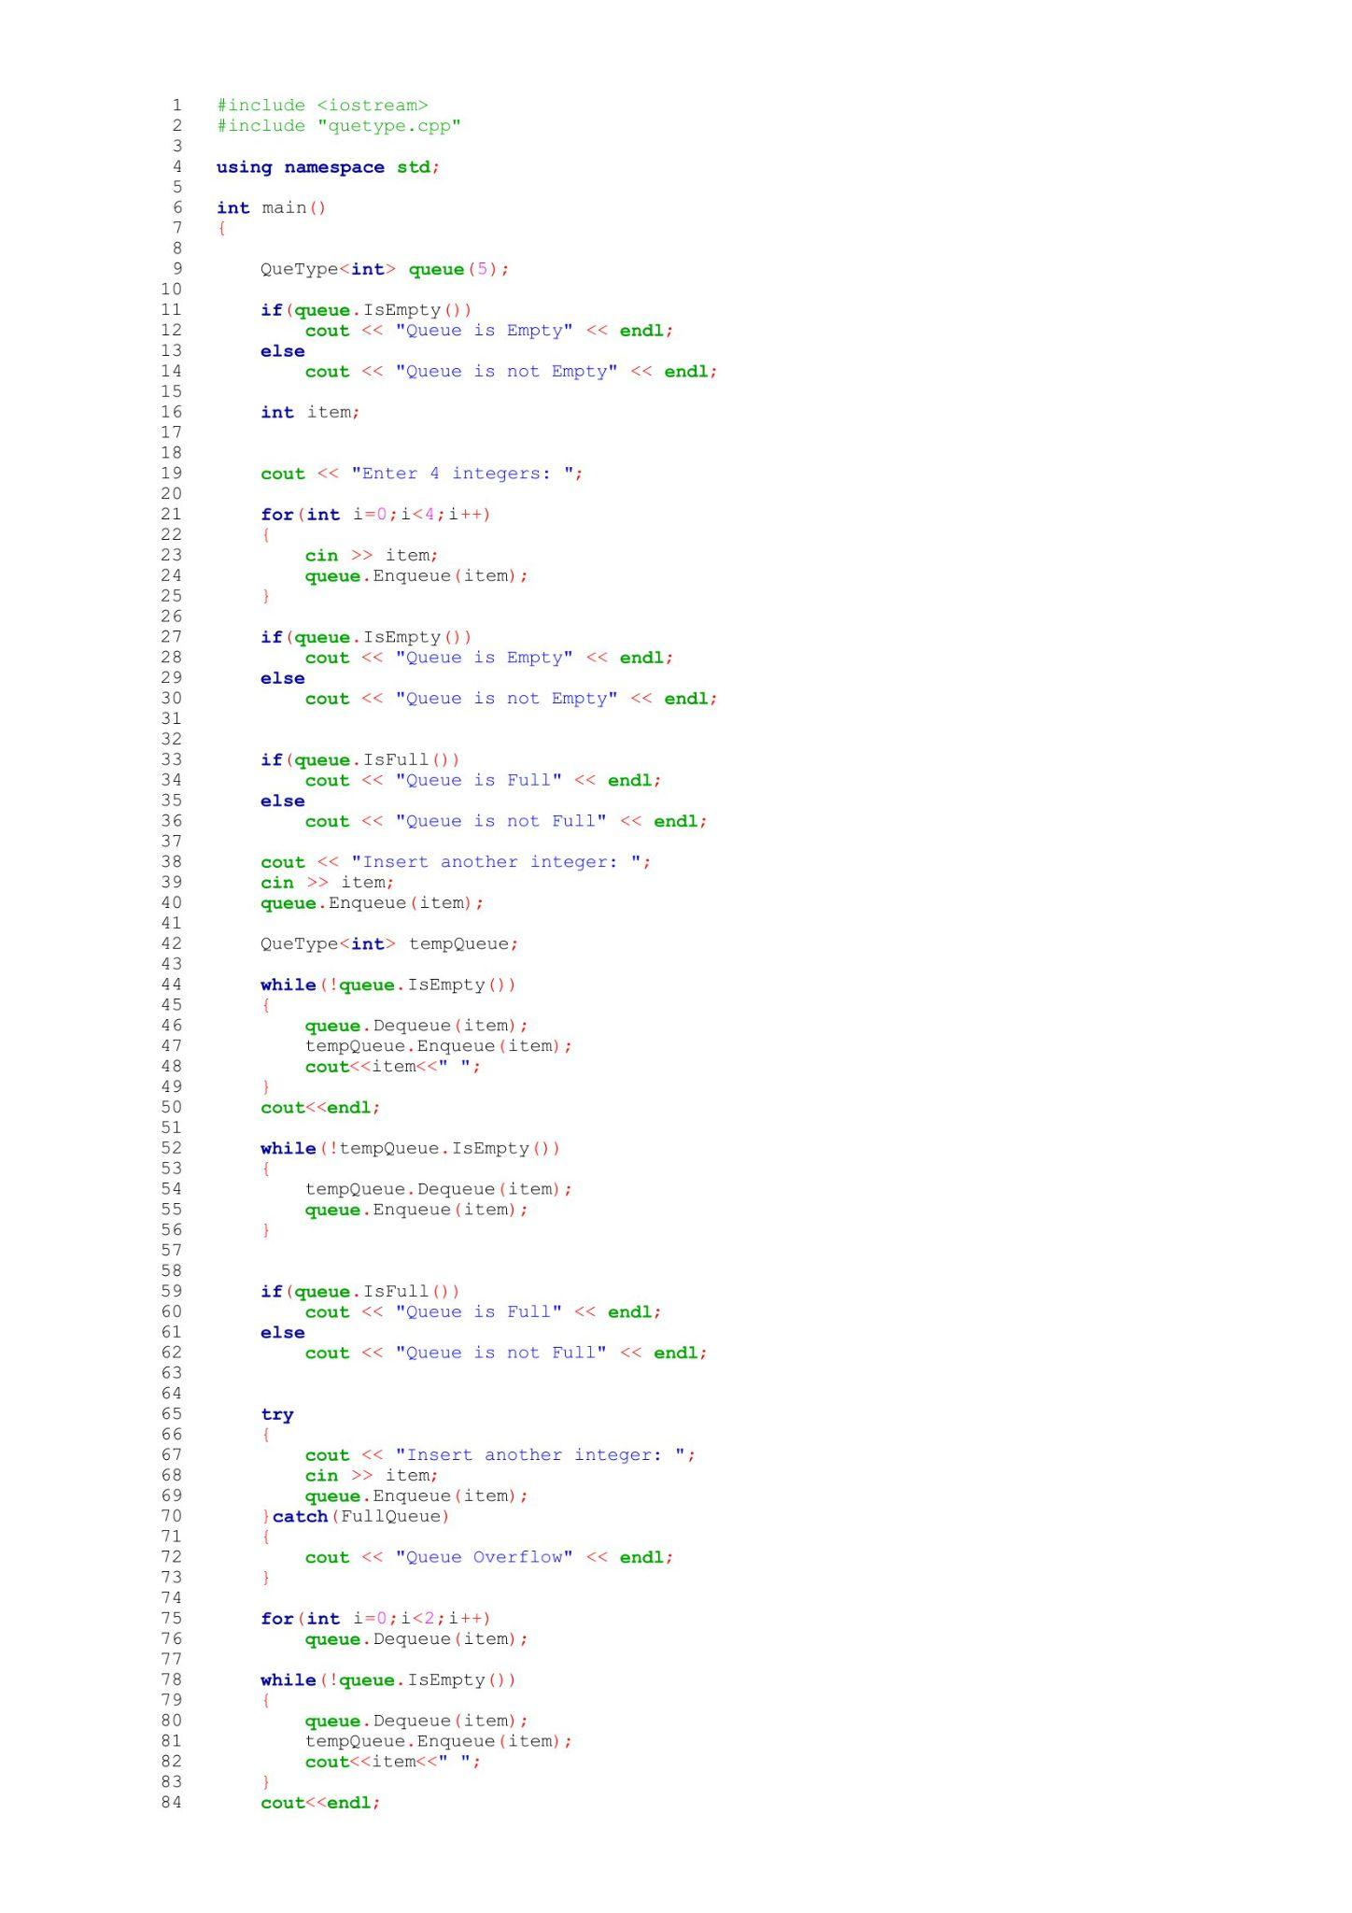
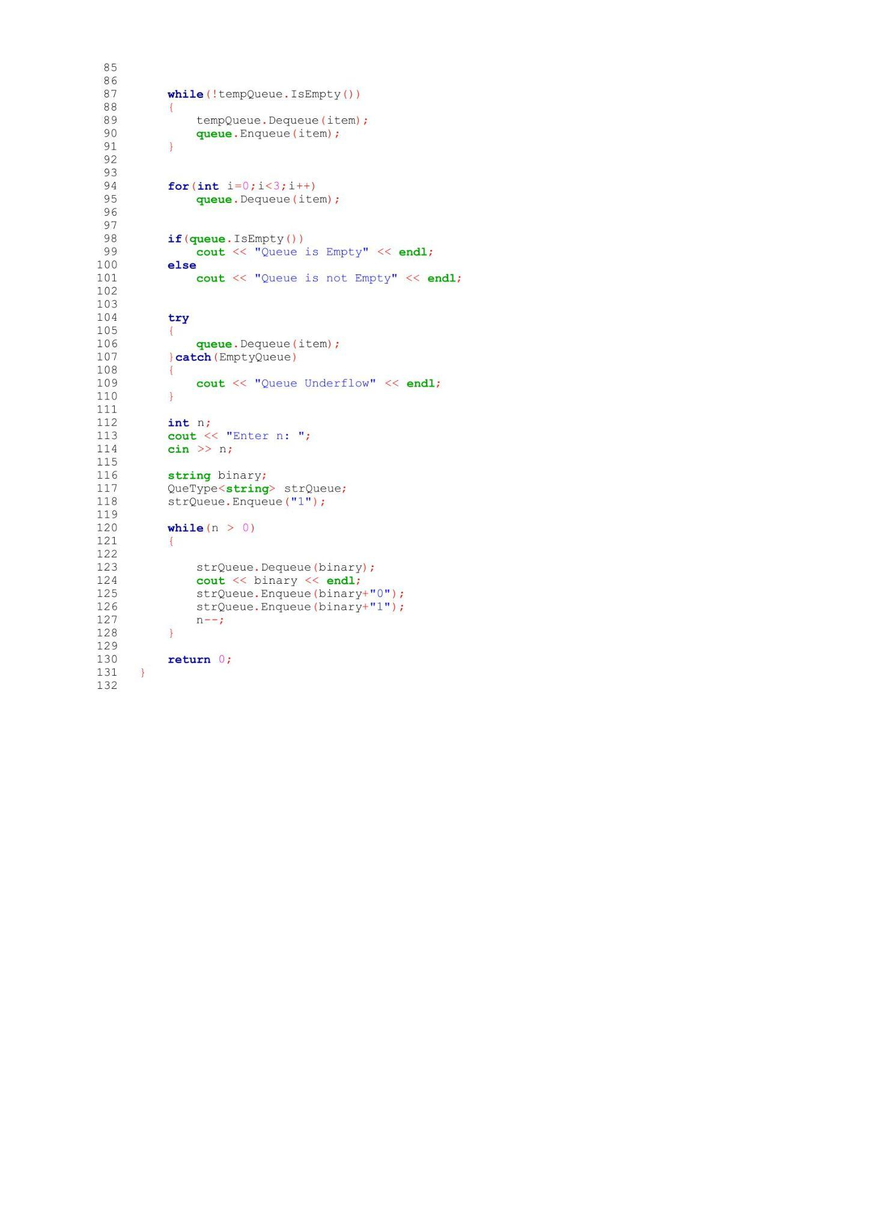
p
